Muslim magazine targets non-Muslim readers
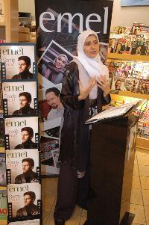
The British public is being targeted by a glossy Muslim lifestyle magazine looking to draw in readers who have been bombarded with negative images of Islam.
It’s the very first time the general public will be able to look between the covers of emel as it sits next to their usual collection of celebrity, fashion and car magazines. They will be offered features, commentaries and interviews giving an insight into today’s Muslim. The magazine also has a mix of alternative food, fashion, travel, gardening and design.
"We’re offering a window into Muslim communities, away from the clichés and stereotypes," says Sarah Joseph OBE, editor and co-founder of emel.
"We aim to bridge the ever increasing gulf of misunderstanding and mistrust."
The magazine shows that there is more to the Muslim communities than religious dogma and international politics. "We express the way Muslims are drawing on a rich cultural heritage and creating something relevant and positive for today’s world," says Joseph. "We believe it is vital to show everyday Muslims engaged in building a constructive future in Britain."
So far emel has been selling successfully through a narrow outlet of Muslim bookstores, community centres and the web. However, recent events and increased demand have resulted in the decision to go mainstream. "People are curious," says Joseph, "and they want to know more about Muslims from Muslims themselves. We feel now, more than ever, the need to fling open the doors and let people in."
Emel, which has subscribers in over thirty countries, begun in 2003 as a bi-monthly and is now going monthly. It has become the first Muslim magazine to achieve mainstream distribution.

